2025 Registration Process Helpful Guide

Before you start: This process will take about 15-20 minutes to complete, depending on whether you have an account or whether your passwords need to be reset. We appreciate your time getting the player registered to play football with us this year. We recognise the process is a little tricky, so we’ve prepared this guide to assist with the registration.

Those who have an existing Account can sign back in to complete their registration. If you can’t recall your Password, Click Forgot Password. New Families will have to set up an account before starting the registration process.

This year, we are back to a two-step registration process. The first Squadi step seems to be working well, PlayFootball has worked well for some families and others have trouble.

Fees for U11s and younger, fees are $295 for the season (plus transaction fees)
Fees for U12s & U13s are $320 for the season (plus transaction fees)

- Squadi (FQ): For club fees and FQ fees
  - For U12s and younger $280.00 if you use the Discount Code: GoldfieldsUnitedFC2025Junior.
  - For U13s $405 as these are competition games played regularly in Townsville.
- PlayFootball v2.0 (FA): For FA fees ($15.00) and finalising registration. You will be automatically directed via a pop-up box to PlayFootball from Squadi.

Please register with an email address you check regularly. Throughout the season, important updates (schedules, notices, event details) will be sent to this address. Please check your spam/junk folder for emails from us (e.g., gufchawks@gmail.com) Staying connected ensures you don’t miss key information! :-)

Note: Registraitons close 27 February 2025

Stage 1: Squadi Registration

- Registration
Can be completed on Desktop and the Phone.
https://registration.squadi.com/login

- Profile will open, select “Actions” on the right hand side, and from the drop down box select “Register”.

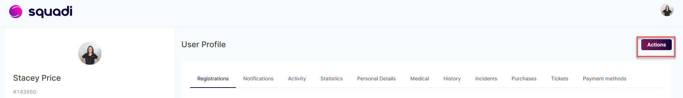

- Participant Selection
- If you or child have registered before, their profile will be available to select
- New registrations, then select +New Participant Registration

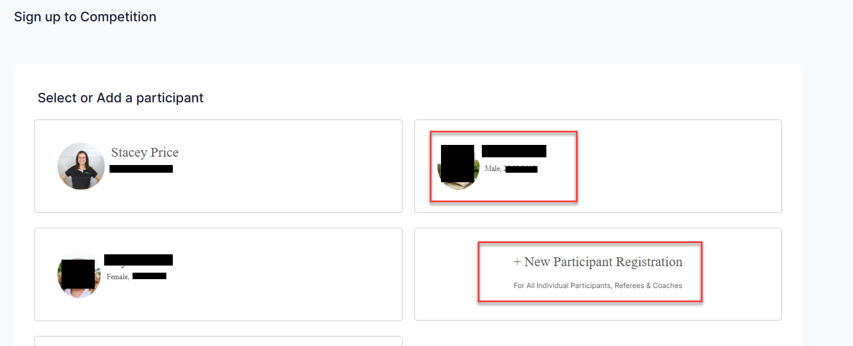

- Existing Participant
Check all details are correct and update anything or check if any areas are missing and update.
Next (bottom of page)

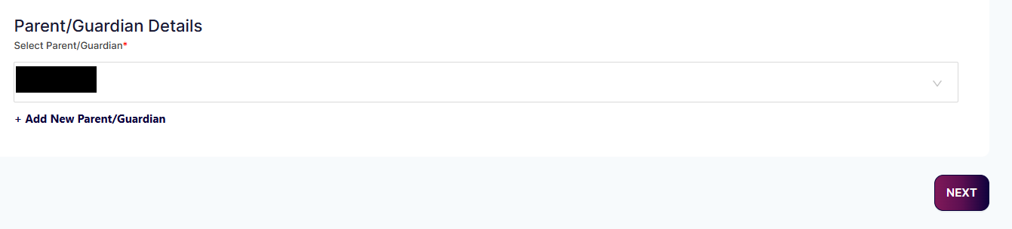
- Search by the Post Code by entering 4820 then selecting the “Search” button.
- From the “Organisation Name”, dropdown select “Goldfields United Football Club”.
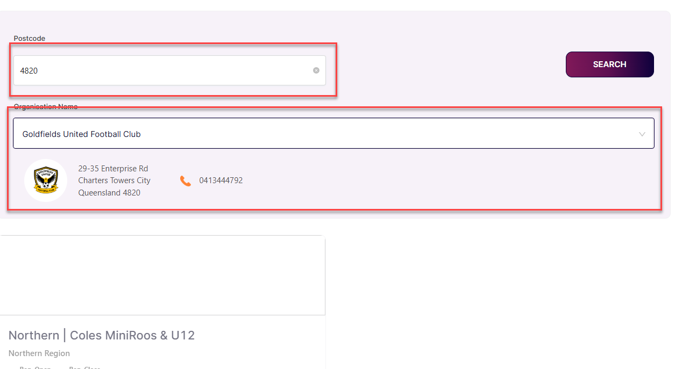
- Select “Northern | Coles MiniRoos & U12” for players born in 2013 or later. This is also the option for Managers and Volunteers to select (if in that position).
- The next page asks you to select your “Membership Details”.
  - For children born in 2014 or later, select the “Coles MiniRoos - Player” checkbox.
  - For children born in 2013 or 2012, select “Outdoor Player Junior - Player”
  - Volunteers, Committee Members and Manager positions are also available here to select for those who need to register. If you are interested in one of these positions please contact us.
- Provide an indication of your preferred children’s Shirt Size. Please note, unfortunately we cannot guarantee this is the size you will be given. We do our best to have sizes, however as we have to order before the season starts, you may be given a different shirt size depending on availability.
- Age Group will be populated based on what they have turned or are turning in 2025. After registrations, Coaches may move players up or down depending on a number of factors including Team Registrations Numbers and skill.

Age Group | Under 5 | Under 6 | Under 7 | Under 8 | Under 9 | Under 10 | Under 11 | Under 12 | Under 13
Year of Birth | 2020 | 2019 | 2018 | 2017 | 2016 | 2015 | 2014 | 2013 | 2012

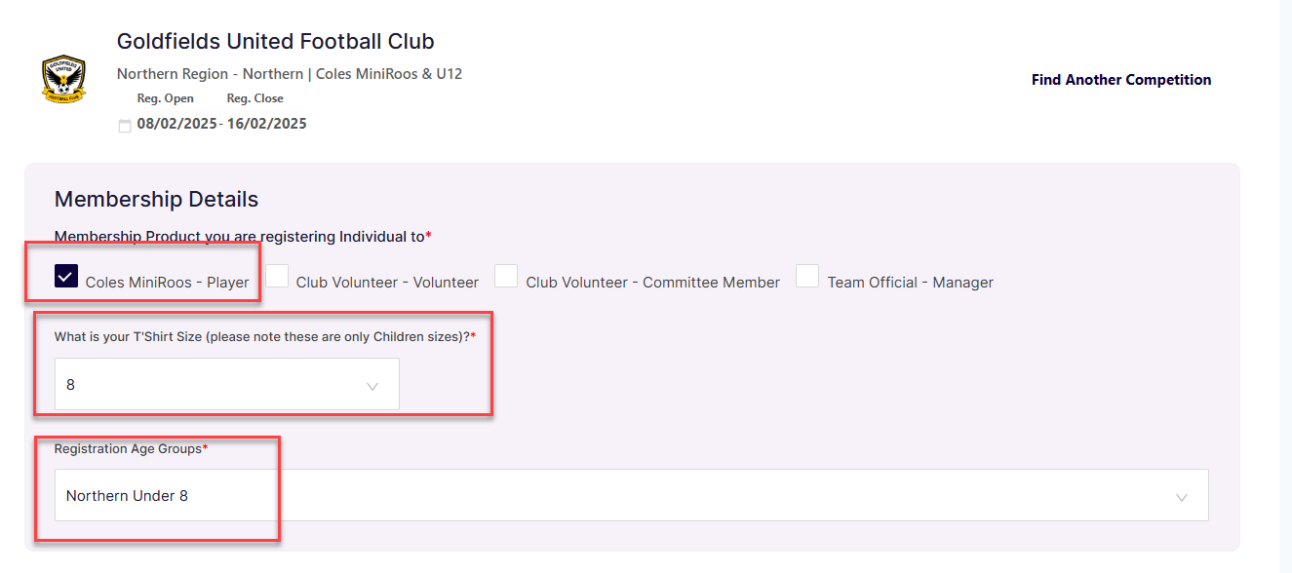

- Personal Info
Following page is your personal information – please complete each section. Once complete – click Add Competition and Membership
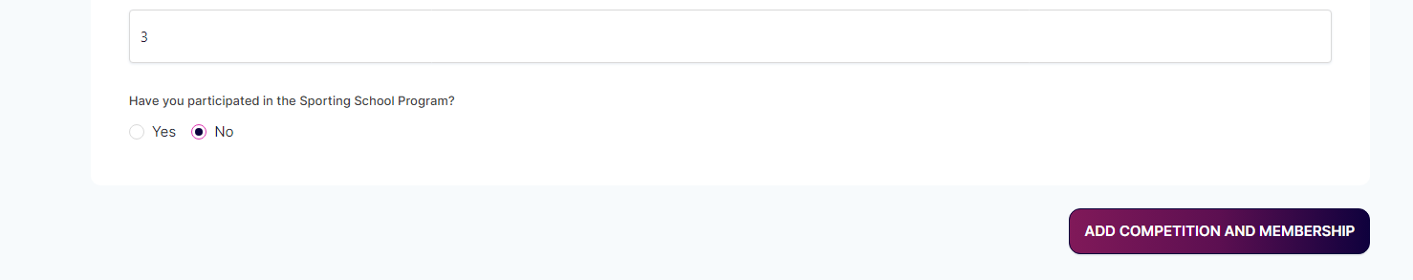

- Payment & discount code

Next step is Payment. PLEASE ENTER the discount code and select “Apply Code” to get a reduced rate:
GoldfieldsUnitedFC2025Junior

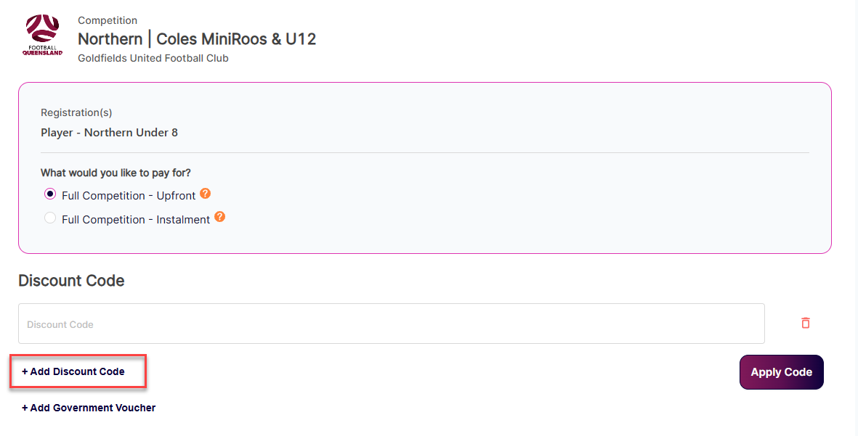

- Enter the Discount Code and Government Voucher (if you have one).
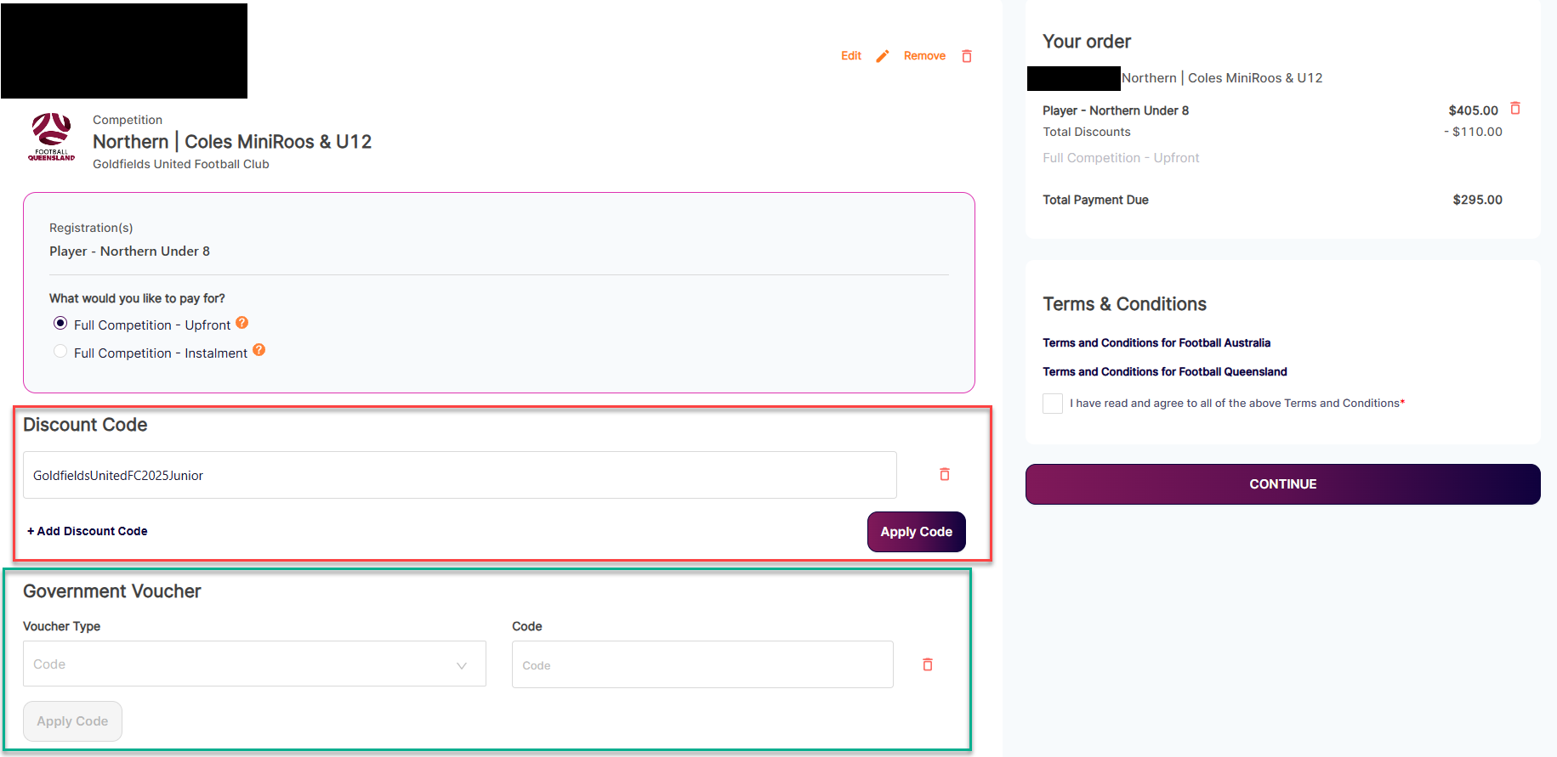
- Terms and Conditions
Click on the links to read the Terms and Conditions for Football Australia and Football Queensland, then click the checkbox on the right to indicate you have read and agreed to the terms.
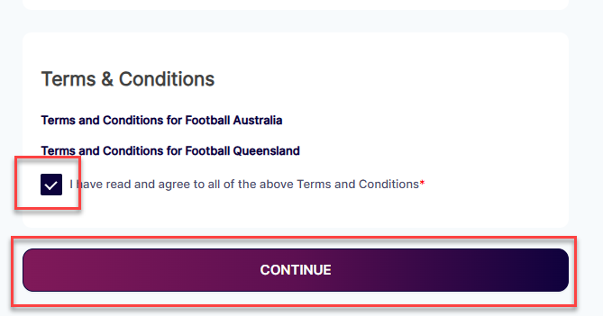

- Select your payment type:
The transaction fee will update once you have entered your credit card or bank detais.

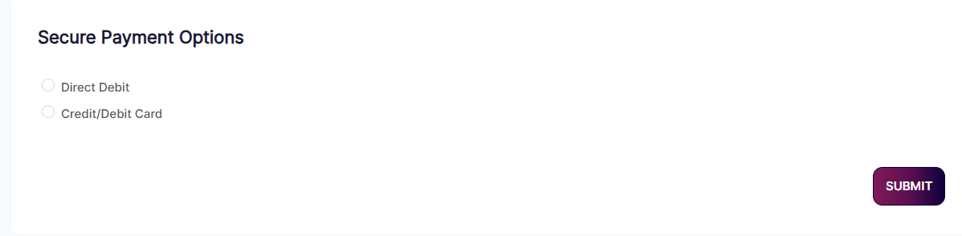

- Fill in your payment details

- Press Submit

Almost there! That’s the Squadi step complete.

Now just the Play Football step.

Once you have completed the Squadi Registration, there is a pop up box that takes you to Football QLD Portal.

STAGE 2 – Football QLD Portal

Tips: During the registration process, you will be advised to have ready, a Photo of your player and a form of Identification i.e. Birth Certificate, however this is not required. You don’t need to upload any documents and the club does not require you to present to us.
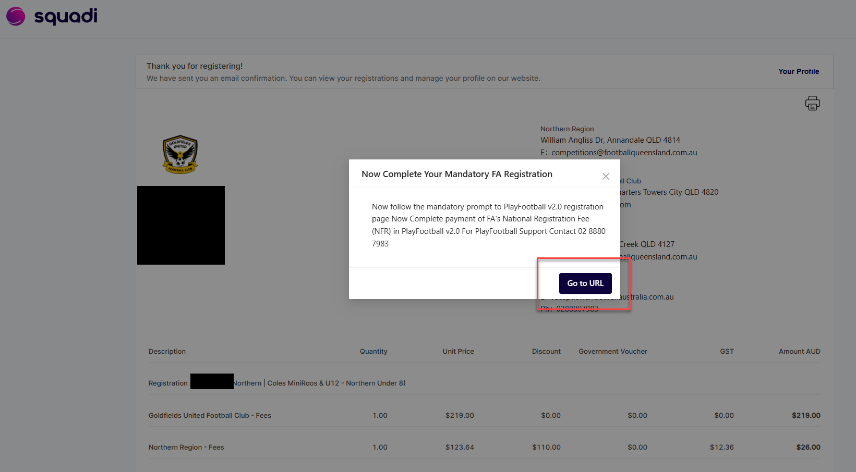
Check family group Visit https://registration.playfootball.com.au/participant?page=profile&tab=2 to check the child you are registering is part of your family group. If not, add the child here before continuing.

Then visit https://registration.playfootball.com.au/participant?page=registrations Then select “My Registrations”

- Red: If you are a returning player
- Yellow if New to Football and registering for the first time.

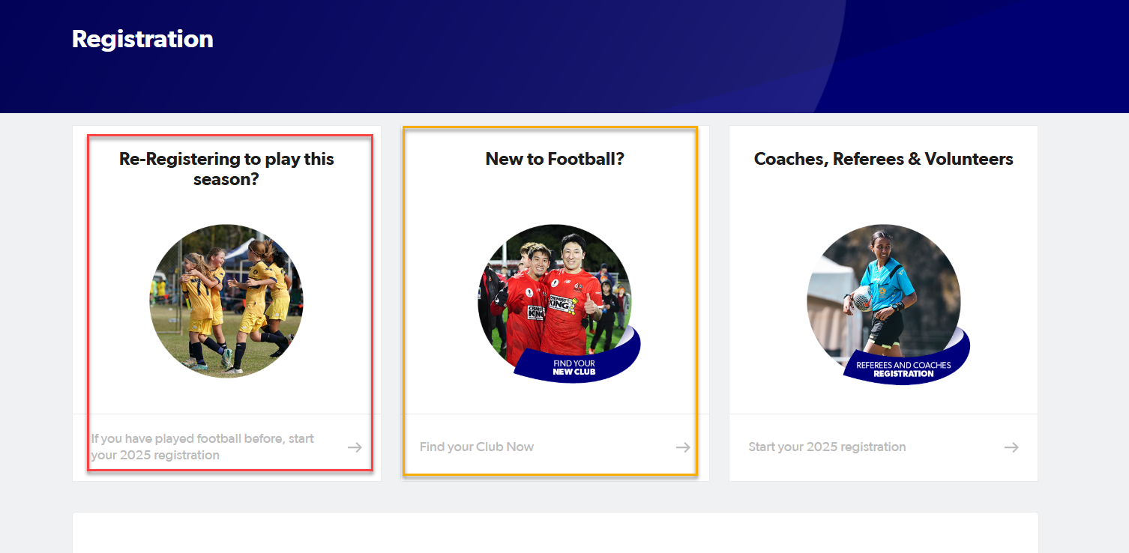

Type in Goldfields in the search box and select the club.
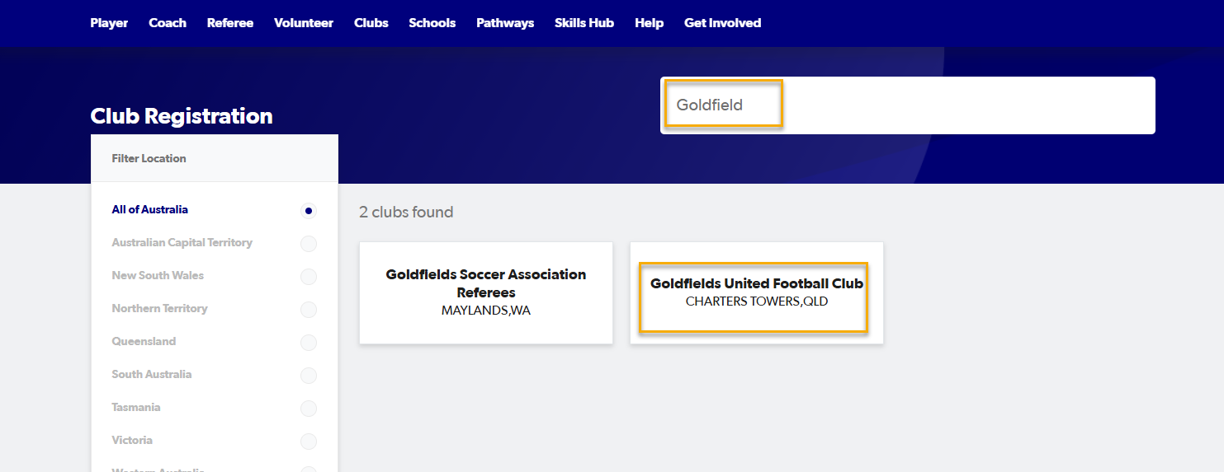

Click Terms and Conditions.
If you can’t remember your password – click forgot password to go through the process.

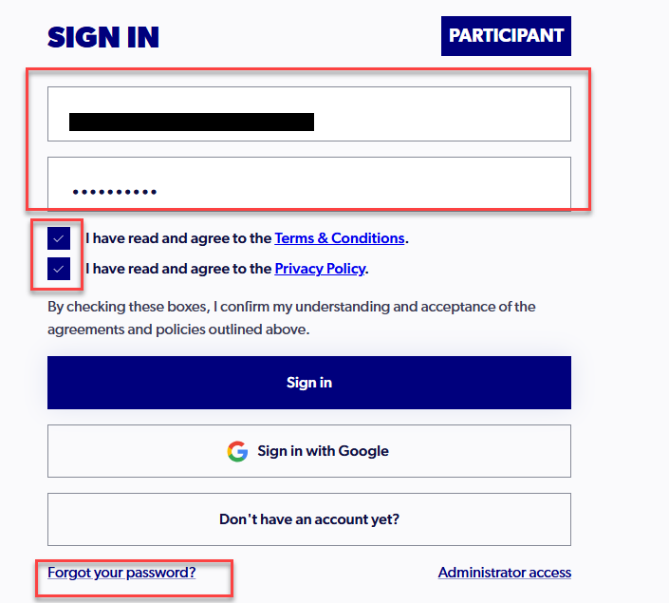

2. If you forgot your password, you may be asked to update your communication preferences. Please choose if you want to receive ticketing information (e.g. for Soceroos or Matilda’s games), fan communications or emails from Football Australia or MiniRoos.

3 Products to choose from – for Mini Roo’s select bottom option. Select “Details”

If registering someone who is older than 11 years, please use Junior (middle option).

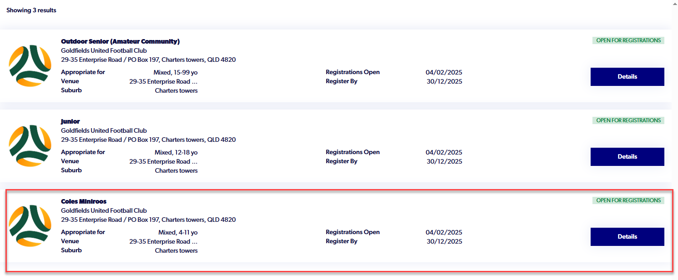

Register

You will be required to pay $15, this is Football Australia portion of the fee. In previous years, this fee was captured in the Squadi Portal.

4. Select “Register”
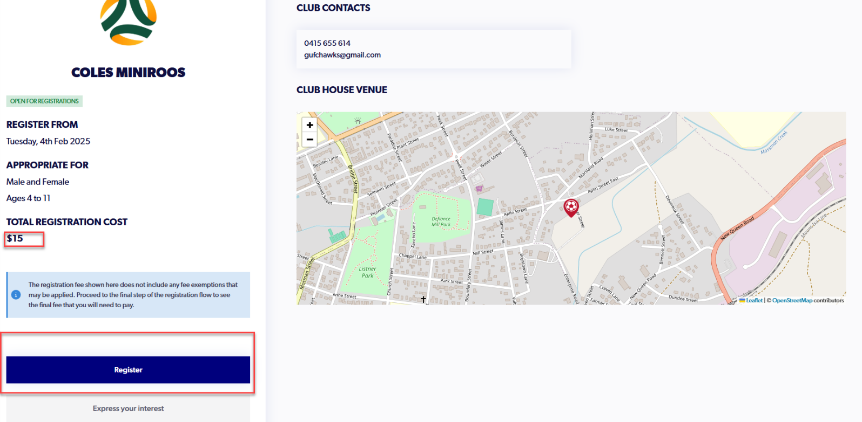

5. As Registering children, you select “Somebody else”
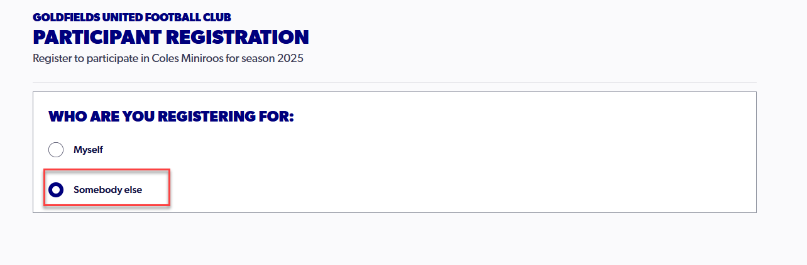

6. Terms and Conditions are displayed. CLICK on each of the lines – and click on the tick boxes. A new window will open with the Terms and Conditions. Return to the Play Football window to review the next item. These will be BLUE before you click on them – they turn GREEN after you click on them and have a green tick.

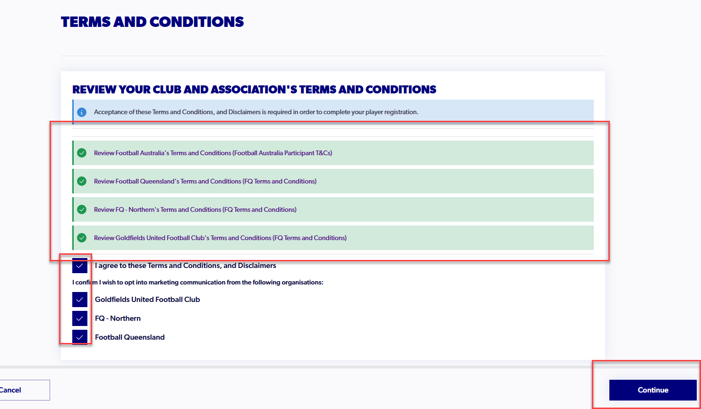

Participant Registration

You’ll get a Participant Registration screen that reminds you to have your credit card and a photo handy.

Reminder: the documents listed are not required. Please ignore that section.

7. Select “Start”.

8. Personal Details (your details not the player) should be populated from registration. Select “Next”. As you complete each section, a green tick will appear against the section title.

Continue through the form completing personal information. Remember – complete EACH LINE.

HINT
If you get to Participants Details and can’t continue, i.e. the box on the bottom right is Grey, something is missing on previous pages. Unfortunately, the system does not highlight what is missing, it can be a phone number or email or drop-down question. Please double check.
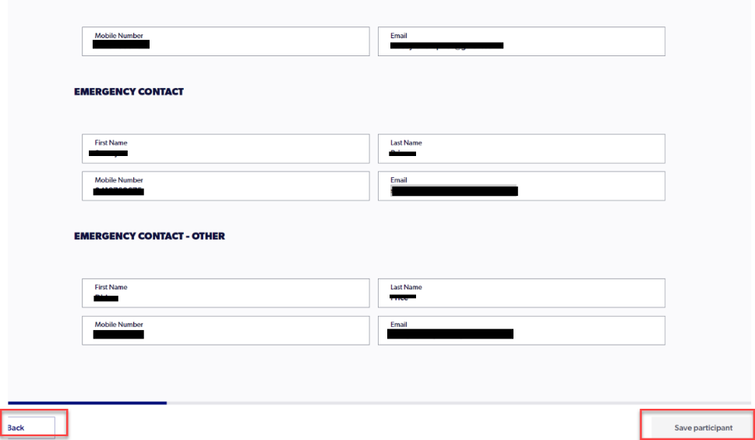

9. Participant Details: Enter the player details to search for existing records. Select Next.

10. Contact details: Enter the emergency contacts and click next.

11. Regulation details: Select “No” for whether the player is on loan from another club and select Next.

12. Additional questions: Complete and select Next.

13. Verify identity: Please upload a photo of the child. This is to help the coaches and managers identify the player.

You will be asked what form of identification, please select any. Reminder: The club does not require you to bring these items in for verification.

14. Payment details
Enter your payment details and submit.
If you get an error at this step, you may need to check the chid is in your family group and try again: adding the child to your family group at: https://registration.playfootball.com.au/participant?page=profile&tab=2

To know you are fulll registered and the child/children are able to play, you should have TWO email confirmations and two payments from your account.

Squadi Play Football
info+registration@squadi.com no-reply@footballaustralia.com.au
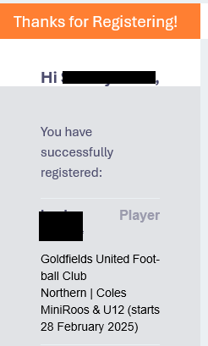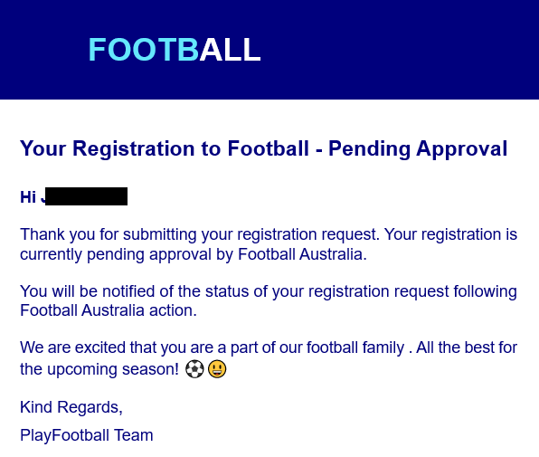

You will also receive an Approval Email. This one is sent once we at the Club Approve your Registration (please allow a day or two for this one to come through as it’s a manual step).
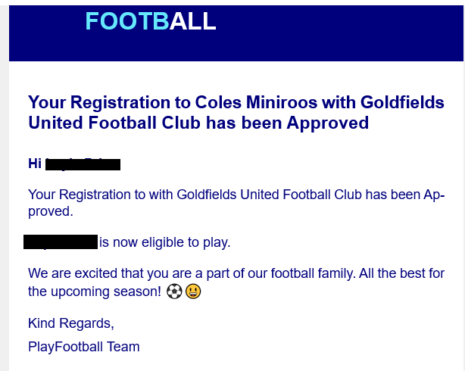

All done!

Thank you for registering with the Goldfield United Football Club.

